**WEEK 7**

**Module 10 – Single Page Application framework – React**

**9. ReactJS-HOL**

**CODE:**

**src/components/ListofPlayers.js**

import React from 'react';

const ListofPlayers = () => {

const players = [

{ name: 'Jack', score: 50 },

{ name: 'Michael', score: 70 },

{ name: 'John', score: 40 },

{ name: 'Ann', score: 61 },

{ name: 'Elisabeth', score: 61 },

{ name: 'Sachin', score: 95 },

{ name: 'Dhoni', score: 100 },

{ name: 'Virat', score: 84 },

{ name: 'Jadeja', score: 64 },

{ name: 'Raina', score: 75 },

{ name: 'Rohit', score: 80 }

];

const below70 = players.filter(player => player.score < 70);

return (

<div>

<h2>List of Players</h2>

<ul>

{players.map((player, index) => (

<li key={index}>Mr. {player.name} {player.score}</li>

))}

</ul>

<h2>List of Players having Scores Less than 70</h2>

<ul>

{below70.map((player, index) => (

<li key={index}>Mr. {player.name} {player.score}</li>

))}

</ul>

</div>

);

};

export default ListofPlayers;

**src/components/IndianPlayers.js**

import React from 'react';

const IndianPlayers = () => {

const allPlayers = ['Sachin1', 'Dhoni2', 'Virat3', 'Rohit4', 'Yuvraj5', 'Raina6'];

const oddPlayers = allPlayers.filter((_, index) => index % 2 === 0); // 0, 2, 4

const evenPlayers = allPlayers.filter((_, index) => index % 2 !== 0); // 1, 3, 5

const [first, third, fifth] = oddPlayers;

const [second, fourth, sixth] = evenPlayers;

const T20players = ['First Player', 'Second Player', 'Third Player'];

const RanjiTrophy = ['Fourth Player', 'Fifth Player', 'Sixth Player'];

const merged = [...T20players, ...RanjiTrophy];

return (

<div>

<h2>Odd Players</h2>

<ul>

<li>First : {first}</li>

<li>Third : {third}</li>

<li>Fifth : {fifth}</li>

</ul>

<h2>Even Players</h2>

<ul>

<li>Second : {second}</li>

<li>Fourth : {fourth}</li>

<li>Sixth : {sixth}</li>

</ul>

<h2>List of Indian Players Merged:</h2>

<ul>

{merged.map((player, index) => (

<li key={index}>Mr. {player}</li>

))}

</ul>

</div>

);

};

export default IndianPlayers;

**src/App.js**

import React from 'react';

import ListofPlayers from './components/ListofPlayers';

import IndianPlayers from './components/IndianPlayers';

function App() {

const flag = true; // Change to false for IndianPlayers output

return (

<div className="App">

{flag ? <ListofPlayers /> : <IndianPlayers />}

</div>

);

}

export default App;

**src/index.js**

import React from 'react';

import ReactDOM from 'react-dom';

import App from './App';

ReactDOM.render(<App />, document.getElementById('root'));

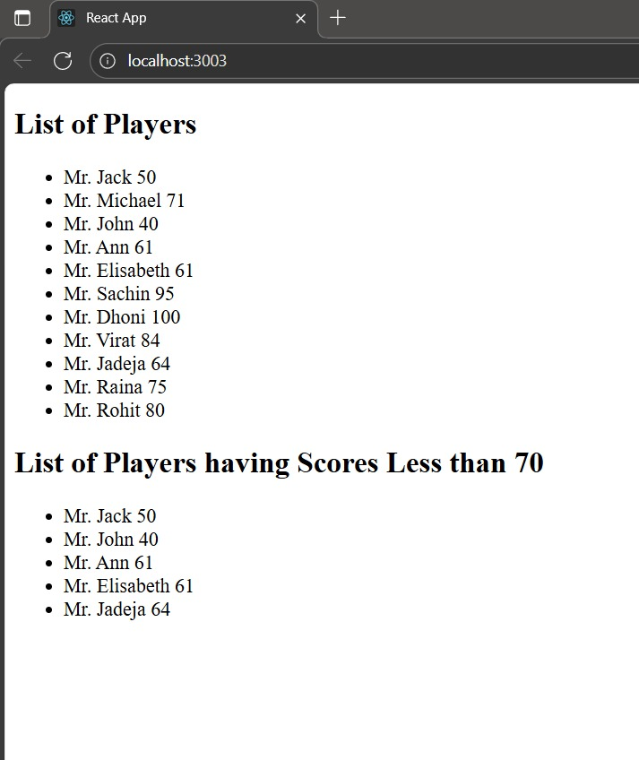**OUTPUT:**

